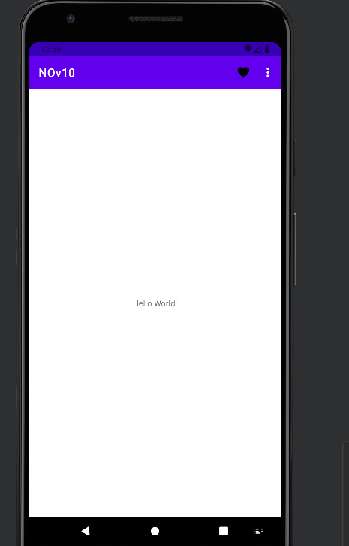

package com.example.nov10  
  
import android.os.Bundle  
import android.view.Menu  
import android.view.MenuItem  
import android.widget.Toast  
import androidx.appcompat.app.AppCompatActivity  
  
class MainActivity : AppCompatActivity() {  
 override fun onCreate(savedInstanceState: Bundle?) {  
 super.onCreate(savedInstanceState)  
 setContentView(R.layout.*activity_main*)  
 }  
  
 override fun onCreateOptionsMenu(menu: Menu?): Boolean {  
 *menuInflater*.inflate(R.menu.*menu*,menu)  
 return true  
 }  
  
 override fun onOptionsItemSelected(item: MenuItem): Boolean {  
 when (item.*itemId*) {  
 R.id.*contact* -> Toast.makeText(this, "You clicked on add contacts", Toast.*LENGTH_SHORT*).show()  
 R.id.*settings* -> Toast.makeText(this, "You clicked on settings option", Toast.*LENGTH_SHORT*).show()  
 R.id.*about* -> Toast.makeText(this, "You clicked on about", Toast.*LENGTH_SHORT*).show()  
 R.id.*help* -> Toast.makeText(this, "You clicked on Help option", Toast.*LENGTH_SHORT*).show()  
  
 }  
 return true  
 }  
}

/*  
package com.example.nov10  
  
import android.os.Bundle  
import android.view.Menu  
import android.view.MenuItem  
import androidx.appcompat.app.AppCompatActivity  
  
class MainActivity : AppCompatActivity() {  
 override fun onCreate(savedInstanceState: Bundle?) {  
 super.onCreate(savedInstanceState)  
 setContentView(R.layout.activity_main)  
 }  
  
 override fun onCreateOptionsMenu(menu: Menu?): Boolean {  
 menuInflater.inflate(R.menu.menu, menu)  
 return true  
 }  
  
 override fun onOptionsItemSelected(item: MenuItem): Boolean {  
 return super.onOptionsItemSelected(item)  
 }  
  
}*/

<?xml version="1.0" encoding="utf-8"?>  
<menu xmlns:tools="http://schemas.android.com/tools"  
 xmlns:android="http://schemas.android.com/apk/res/android"  
 xmlns:app="http://schemas.android.com/apk/res-auto">  
 <item  
 android:id="@+id/about"  
 android:title="ABOUT US"  
 android:orderInCategory="1"  
 tools:ignore="HardcodedText" />  
 <item  
 android:id="@+id/settings"  
 android:title="SETTINGS"  
 android:orderInCategory="2"  
 android:icon="@drawable/settings_option"  
 app:showAsAction="never"  
 tools:ignore="HardcodedText" />  
 <item  
 android:id="@+id/contact"  
 android:title="CONTACT US"  
 android:orderInCategory="3"  
 tools:ignore="HardcodedText" />  
 <item  
 android:id="@+id/help"  
 android:title="HELP"  
 android:orderInCategory="4"  
 android:icon="@drawable/favourites"  
 app:showAsAction="always"  
 tools:ignore="AlwaysShowAction,HardcodedText" />  
</menu>